**Parent Child component relationship**

In a Angular app, The components are generally created with a hierarchy and information flow will be usually from top to bottom. If we call a component within a component then the component in which we call is called parent and the component that is called is called as child component.

As per the app so far, we have the root component and we can generate a new component using the command

a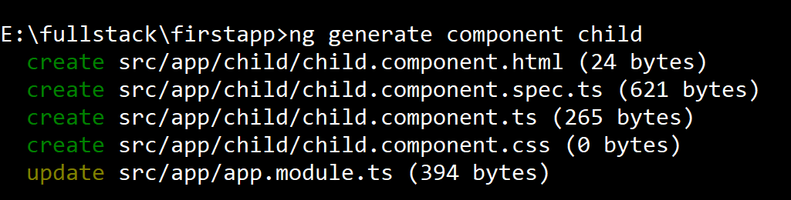

The component is generated in the app folder as follows

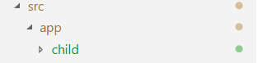

The child component typescript file appears this way

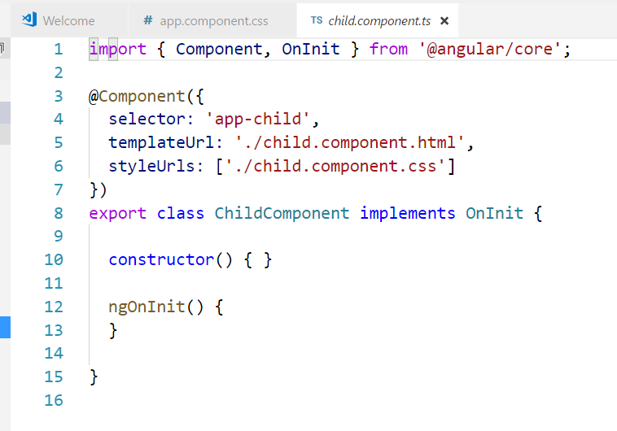

Declare a variable called data as follows

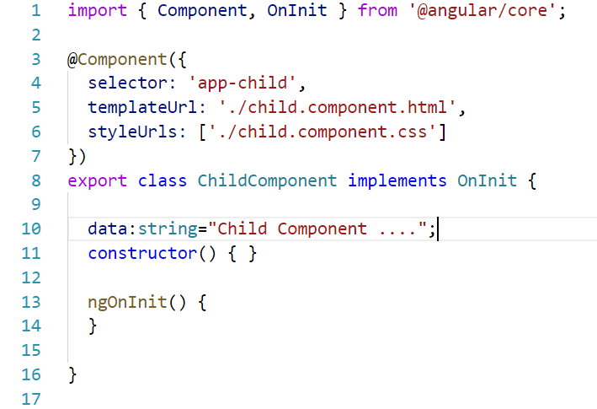

And in the template file(child.component.html),

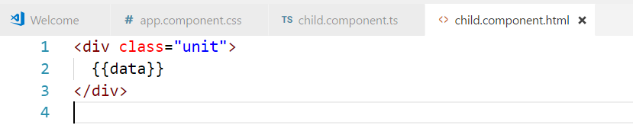In the css file

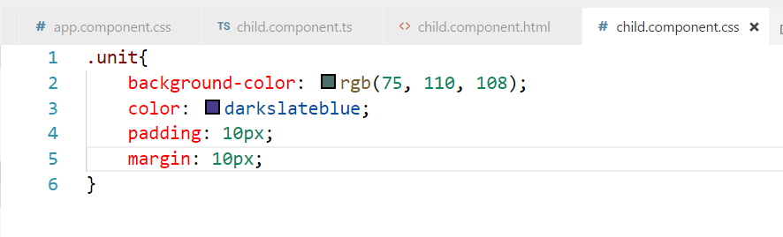Now that component code is ready, This component can be called in root component by using the selector <app-child>

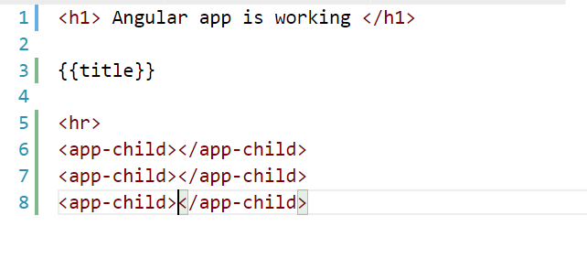Now if we check the output we find the page as it is shown below.

